-> Java is a programming language & developed by Sun Microsystem Company

-> Oracle company acquired Sun Microsystem

-> Java is under license of Oracle Company

-> Java is a high level programming language & simple programming language to develop project

-> Java program files will have .java as extension

Ex: Demo.java, Hello.java, Driver.java, Calculator.java etc..

-> We can't execute .java files directly

-> Java Programs should be converted into Machine understandable format to execute

-> Java Programs (.java file) contains source code

-> We need to compile java source code into byte code using java compiler (javac)

Ex: javac Demo.java

-> When we compile java code it will create .class file

-> We need to execute .class file to run the java program

Ex: java Demo

-> When we run java program using java command, JVM will start and it will execute java program

Note: JVM stands for Java Virtual Machine

-> JVM will convert byte code into machine understandable code

-> Java project contains several java programs (.java files)

-> We need to compile project source code into byte code

-> When we compile project source code we will get .class files

-> To deploy java project, we will package all .class files as JAR or WAR file

JAR: Java Archieve

WAR: Web Archieve

-> Standalone java projects will be packaged as JAR file

-> Web Applications will be packaged as WAR file

Note: The software which is specific to only one computer i.e called StandAlone application

**Maven**

-> Maven is a free and open source software given by Apache Organization

-> Maven s/w is developed using Java programming language

-> Maven is used to perform Build Automation for java projects

-> Maven is called as Java Build Tool

**What we can do using maven**

1) We can create initial project folder structure using maven

2) We can download "project dependencies" using maven

(ex : springboot, hibernate, kafka, redis, email, log4j, junit, security...)

-> To develop one java project we will use several frameworks like spring, hibernate etc along with Java

-> We need to download those frameworks and we should add to our java project

-> These frameworks we are using in our project are called as our project dependencies

-> Instead of we are downloading dependencies, we can tell to maven s/w to download dependencies

Note: Required dependencies we will add in "pom.xml" file then maven s/w will download them

-> pom stands for project object model

-> When we create maven project then pom.xml file will be created automatically

-> pom.xml will act as input file for maven software

3) We can compile project source code using maven

4) We can package java project as jar or war file using maven

**Maven Installation**

1) Download and install Java software

-> When we install java we will below 2 things

a) JDK (Java Development Kit)

b) JRE (Java Runtime Environment)

-> JDK contains set of tools to develop java programs and compile the program

-> JRE contains platform/environment which is used to run java programs

Link To Download Java : https://www.oracle.com/in/java/technologies/javase/javase8-archive-downloads.html

2) Set JAVA_HOME in Environment Variables (System Env Variables)

User Environment Variables: Specific to particular account which logged in our PC

System Envrionment Variables : For All Accounts it will be applicable

Note: Y Environment variables means to tell to Operating System my java is available in so and so location iam going to set JAVA_HOME in Environment Variable

JAVA_HOME we are configuring upto Jdk

(Y environment variable means environment variables will be used by OperatingSystem to find the locations of our softwares)

Note: Environment Variables will be used by operating system

JAVA_HOME = C:\Program Files\Java\jdk1.8.0_202

3) Set Path for JAVA (Go to System Env Variables -> Env Variables -> System Variables -> Select Path and Click on Edit then add JDK path)

Path = C:\Program Files\Java\jdk1.8.0_202\bin

4) Verify Java installation by executing below command in "Command Prompt"

> java -version

Note: It should dipslay java version which we have installed

Note : Y Iam Installing Java means Maven software is developed by using java language, if u want to run the Maven then u need the java so thats y we install java first

5) Download Maven software from Apache website

Link to download Maven: https://maven.apache.org/download.cgi

File Name: apache-maven-3.8.5-bin.zip (Binary Archive)

6) Extract Maven Zip file -> Copy extracted maven folder and paste it in "C" drive

7) Set MAVEN_HOME in System Environment Variables

MAVEN_HOME = C:\apache-maven-3.8.5

Note: MAVEN_HOME is going to tell where is the maven software in the system

8) Set Path for Maven in System Environment Variables

Path : C:\apache-maven-3.8.5\bin

9) Open Command Prompt and verify Maven Installation using below command

> mvn -version

--------------------------------------------------------------------------------------------------------------

**Maven Terminology**

archetype

groupId

artifactId

packaging

-> Archetype represents what type of project we want to create

=> maven-archetype-quickstart : It represents java standalone application

=> maven-archetype-webapp : It represents java web application

Note: Maven providing 1500+ archetypes

-> groupId represents company name or project name

-> artifactId represents project name or project module name

-> packaging represents how we want to package our java application (jar or war)

**Creating standalone application using maven**

1) Create one folder for maven practise

2) Open Command prompt from that folder

3) Execute below command to create maven project

>> mvn archetype:generate -DgroupId=in.ashokit -DartifactId=01-Maven-App -DarchetypeArtifactId=maven-archetype-quickstart -DinteractiveMode=false

4) Once project created verify project folder structure

01-Maven-App

- src

- main

-java

- test

-java

- pom.xml

src/main/java : Application source code (.java files)

src/test/java : Application Unit Test code (.java files)

pom.xml : Project Object Model (Maven configuration file)

5) We can add dependencies in pom.xml file

6) We can find maven dependencies in www.mvnrepository.com website

7) Add below dependency in pom.xml file

<dependency>

<groupId>org.springframework</groupId>

<artifactId>spring-core</artifactId>

<version>5.2.22.RELEASE</version>

</dependency>

**How maven will download dependencies**

-> Maven will download dependencies using repository

-> In Maven we have 3 types of repositories

1) Central Repository

2) Remote Repository

3) Local Repository

-> central repository is maintaining by apache organization

-> every company will maintain their own remote repository

-> Local repository will be created in our system (Location : C://users/<uname>/.m2)

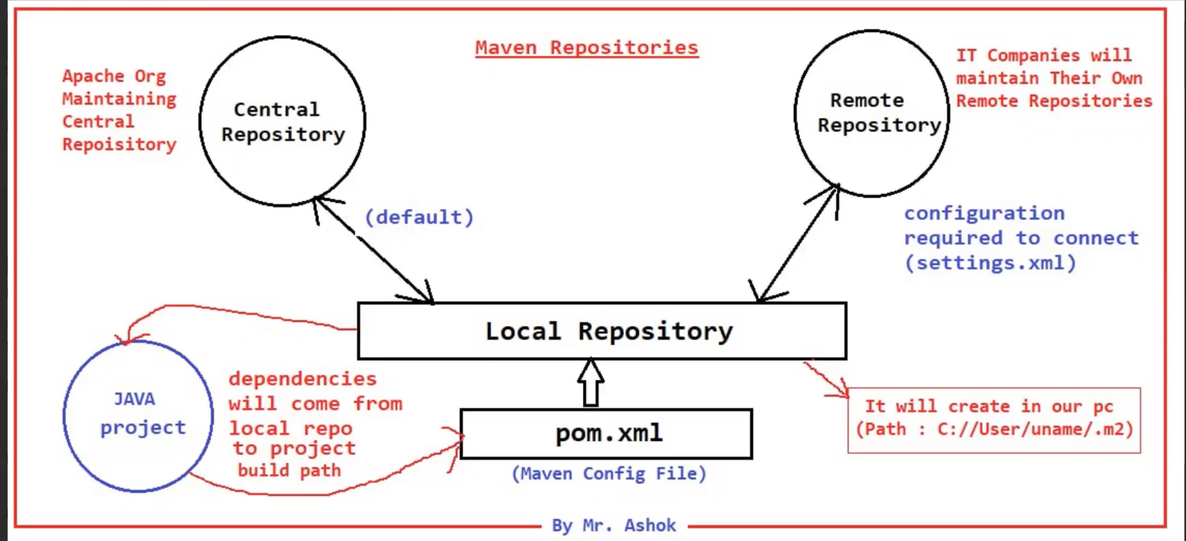

-> When we add dependency in pom.xml, maven will search for that dependency in local repository. If it is available it will add to project build path.

-> If dependency not available in local repository then maven will connect to Central Repository or Remote Repository based on our configuration.

Note: By default maven will connect with central repository. If we want to use remote repository then we need to configure remote repository details.

Note: Every software company will maintain their own remote repository (Ex: JFrog)

**Configuring Remote Repository**

<repositories>

<repository>

<id>id</id>

<url>jfrong-repo-url/</url>

</repository>

</repositories>

**Maven Goals**

-> To perform project build activities maven provided several goals for us

clean

compile

test

package

install

-> clean goal is used to delete target folder

-> compile goal is used to compile project source code. Compiled code will be stored in target folder

compile

.java ------------> .class

-> test goal is used to execute unit test code of our application (Junit code)

-> package goal is used to generate jar or war file for our application based on packaging type available in pom.xml file.

Note: jar or war file will be created in target folder.

-> install goal is used to install our project as a dependency in maven local repository.

Note: Every maven goal is associated with maven plugin. When we execute maven goal then respective maven plugin will execute to perform the operation.

Syntax : mvn <goal-name>

Note: We need to execute maven goals from project folder

creating web application using maven

+++++++++++++++++++++++++++++++++++++++

>> mvn archetype:generate -DarchetypeArtifactId=maven-archetype-webapp -DgroupId=in.ashokit -DartifactId=01-maven-web-app -DinteractiveMode=false

----------------------------------------------------------------------------------------------------

What is Java ?

What is source code ?

What is Byte code ?

What is machine understandable code ?

Java Program Execution Process

What is JDK

What is JRE

What is JVM

What is Project Dependency? (Ex : hibernate, spring, kafka, redis etc)

What is Maven

What are the advantages of Maven

Java Installation

Setting JAVA_HOME & JDK PATH

Maven Installation

setting MAVEN_HOME & Maven Path

Maven Terminology

- archetype

- groupId

- artifactId

- version

- packaging

Pom.xml

Adding dependency in pom.xml

Java Standalone project creation using Maven

Maven Project Folder Structure

Java Web application creating using Maven

Maven Repositories

- Local Repository

- Central Repository

- Remote Repository

Maven Goals

- clean

- compile

- test

- package

- install

Maven Plugins

-------------------------------------------------------------------------------------------------------

